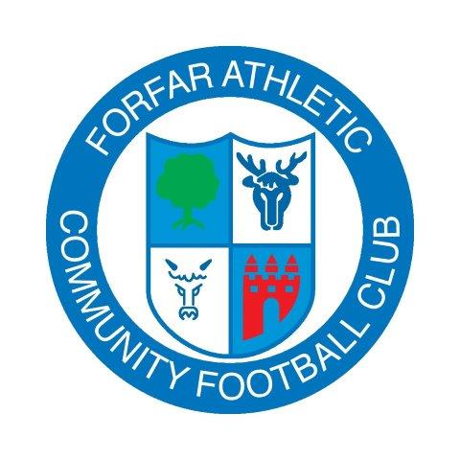

Forfar Athletic Community Football Club

3 Strike Rule

Forfar Athletic Community Football Club expects everyone associated with the club to display high standards of behaviour at all times. As such, we have developed our players codes of conduct and the 3 strike rule detailed below.

This will be implemented should any player and Parent/Guardian fail to adhere to the standards of behaviour we expect. These measures are in place to ensure the safety and well-being of all our players, coaches and managers.

Strike 1 Suspension from the club for a period of a week - all training and matches during this period

Any player displaying unacceptable behaviour will receive a verbal warning and the parents will be informed. This will be recorded officially

Unacceptable behaviour may include, but is not limited to:

- Foul language
- Bullying - verbal, cyber or physical
- Lack of respect for Managers, Coaches, Referees and team-mates
- Failing to follow reasonable instructions
- Damaging club property

Strike 2 Suspension from the club for a calendar month - all training and matches during this period

Strike 3 Removal from the team and club
If persistent poor behaviour continues the player will be removed from the club permanently.

